

**They’re Back!!! Beautiful 9” Flowering Hearty Mums**

(Sponsored by the SDJCA Class of 2025)

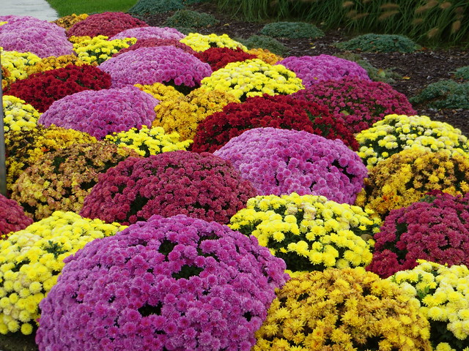

Each year our 8th Graders are asked to sell Fall Mums with all proceeds going toward their 8th grade trip and class gift to our school. The quality and pricing of the mums is exceptional, One plant for $10 and 3 for $28! These mums compare in size to the Large Mums local stores sell for $12+ each and come in a variety of colors for you to choose from at pick-up.! They may be left in their pots for fall décor, or they may also be planted with a great chance of surviving for years to come. If you have any questions, please contact Mariah Bender at 630-864-7324. We will have several different pick-up times announced in the next few weeks with additional stock (if available) sold at Oktoberfest. Don’t forget to ask the family and let neighbors know!! The more you buy, the more you save, the more you help our 8th graders have an amazing class trip!!

One 9” Mum plant for $10.00 or Three 9” Mum plants for $28.00

Please send in your order and payment to the school office by Thursday Sept. 26th.

------------------------------------------------------------------------------------------------------------------ Family Name______________________________________________________________________________

Telephone # ____________________________ E-mail Address ____________________________

# of Mum Plants Ordered: ________________

Payment: Cash or Check (payable to SDJCA, please) Total Cost of Order:

$ ________________ Check # ____________________